GVSI USB DMI Module Installation Instructions

Only models with the DMI tools in .ZIP format can be used on the USB stick.
Single left-click the file.
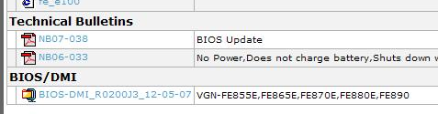
.ZIP format icon on GVSI

When the .zip file has been downloaded, windows XP will display the following dialog box. Click ‘OK’
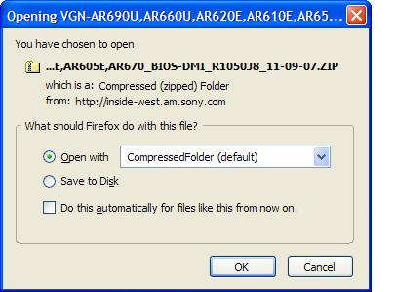

When the .ZIP file is opened in a new window, there will be a folder for the model family inside. Drag the folder to the root directory of the USB stick.
